**2023**

**Year 12 Earth and Environmental Science – Unit 3**

**Task 7: Fossils and Fossil Fuels Test**

**Weighting: 9%**

**MARKING KEY**

**Name: __________________________**

**Date: ___________________**

|  |  |
| --- | --- |
| **Total Mark** |  |

*I acknowledge that all the information contained in this task is my own work and not taken from other sources. If other sources have been used they have been acknowledged in my references.*

____________________________________

(Student Signature)

*Please see SEQTA for teacher feedback and comments.*

1. Fill in the blanks in the flow chart for oil and gas formation using the provided word bank. (7 marks) (2016 EST)

|  |  |  |  |  |
| --- | --- | --- | --- | --- |
| Three to six | Heat | Sea floor | Pressure | Sedimentary |
| Impermeable rock | Metamorphic | Buried | Igneous | Ocean |

Organic matter settles onto the ________SEA FLOOR___________

It is then _________BURIED__________ to a depth of about ___3-6________ km.

It is subjected to ______HEAT________ and ________PRESSURE_________.

It migrates through ________SEDIMENTARY_____________ rock until it is trapped by

______IMPERMEABLE ROCK_______.

1. Describe the differences between fossils and fossil fuels. (2 marks)

1 MARK – FOSSILS ARE THE REMAINS OF LIVING THINGS THAT LIVED IN THE PAST

1 MARK – FOSSIL FUELS ARE THE ENERGY-RICH SUBSTANCES OF THESE REMAINS

1. While exploring a new beach site, geologists identified a layer of fossilised shells in a limestone cliff formation. At the time when the shell layer was forming, there would have been many other animals living in the area, including marine organisms with soft bodies. Outline why only the fossils found in the rock face were from shellfish. (2 marks) (2019 EST)

1 MARK – SOFT BODY PARTS DECOMPOSE QUICKLY SO ARE NOT COMMONLY PRESERVED

1 MARK – SHELLFISH CONTAIN HARD SHELL PARYS WHICH DID NOT DECOMPOSE AFTER THEY WERE COVERED IN SEDIMENT

Or ANY SIMILAR RELEVANT ANSWERS

1. List three different types of fossils. (3 marks)

|  |  |  |  |  |
| --- | --- | --- | --- | --- |
| 1. BODY FOSSIL |  | 1. TRACE FOSSILS |  | 1. FOOTPRINTS |

1. Oil and natural gas, and coal are both considered fossils fuels however they are formed differently. List two differences and two similarities in the formation of them. (4 marks) (2020 EST)

|  |  |
| --- | --- |
| Similarities | Differences |
| FORM OVER MILLIONS OF YEARS | COAL IS FORMED FROM PLANTS |
| FORM IN LOW OXYGEN ENVIRONMENTS | OIL AND GAS IS FORMED FROM PLANTS AND ANIMALS |

1. Explain why fossil fuels are considered non-renewable resources. (2 marks)

1 MARK FOR THEY TAKE MILLIONS OF YEARS TO FORM

1 MARK ONCE THEY ARE GONE THEY CANNOT BE REUSED

1. Identify two negative impacts of using fossil fuels. (2 marks)

ANY TWO MARKS FOR:

GLOBAL WARMING OR INCREASING CO2 EMISSIONS OR OIL SPILLS DAMAGING MARINE LIFE OR ANY RELEVANT ANSWER

1. What are two environmental conditions required for fossilisation to occur. (2 marks)

2 MARKS FOR ANY OF THE BELOW

LOW ENERGY ENVIRONMENT or FOSSILS WERE UNDISTURBED or LOW OXYGEN CONDITIONS or BURIED RAPIDLY or PROTECTED FROM BREAKING DOWN

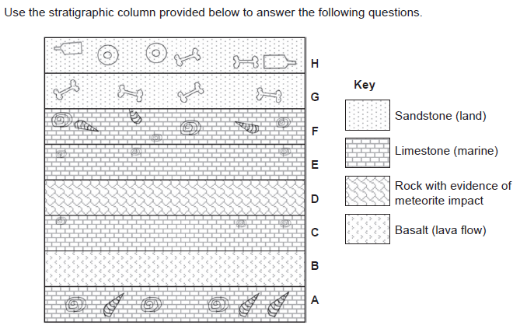

1. A scientist concludes that Layer E has fewer fossils because of the impact of a meteorite. Give one reason why a meteorite impact is linked to species loss. (2 marks) (2016 EST)

DETAILED REASON COULD INCLUDE:

TSUNAMI CAUSES FLOODING OF COASTAL COMMUNITIES

HEAT FROM IMPACT LEADING TO FIRES

ASH AND DUST CAUSING GLOBAL COOLING

DEBRIS COVERING NEARBY AREAS

SHOCKWAVES FROM IMPACT KILL ANIMALS

ANY REASONABLE ANSWER

1. There is a marine layer at F and a terrestrial (land) layer at G. identify and explain an Earth process that could account for this change. (2 marks) (2016 EST)

1 MARK FOR IDENTIFYING + 1 MARK FOR EXPLAINING PROCESS

CLIMATE CHANGE + SEA LEVEL FALLS BECAUSE WATER LOCKED IN ICE CAPS

CONTINENTAL COLLISION + ACCESS TO SEA BLOCKED OFF

CRUSTAL REBOUND + SEA LEVEL FALLS WHEN LAND LEVELS RISE

Oil and gas were ‘made’ over millions of years form plants and animals. A group of Earth and Environmental Science students decided to investigate if the amount of plankton buried under sediment impacted the amount of oil and gas that might form. As they do not have millions of years to conduct this research, they work with biogas instead. As biogas forms from rotting plant and animal material in a matter of days.

1. Identify the following variables for this investigation. (4 marks)

Independent variable: _______AMOUNT OF PLANKTON_____________

Dependent variable: _________AMOUNT OF BIOGAS PRODUCED__________

Two controlled variables: _____SAME CONTAINER SIZE **OR** SAME TIME PERIOD **OR**  KEEP AT SAME TEMPERATURE **OR** MEASURE GAS THE SAME WAY______

1. Write a hypothesis for this investigation. (2 marks)

2 MARKS – STATEMENT SHOWING THE RELATIONSHIP BETWEEN INDEPENDENT AND DEPENDENT VARIABLES.

OR 1 MARK – STATEMENT MADE ABOUT PLANT/ANIMAL MATERIAL AND BIOGAS

Upon completing the investigation, the students came up with the below results.

|  |  |
| --- | --- |
| Plankton Amount (grams) | Biogas Produced (cubic meters) |
| 50 | 0.75 |
| 100 | 1.23 |
| 150 | 1.85 |
| 200 | 2.41 |
| 250 | 2.95 |
| 300 | 3.57 |
| 350 | 4.14 |

1. Use the below space to create a graph based on the student data. (4 marks)

1 MARK – TITLE 1 MARK - CORRECT AXIS LABELS WITH UoM

1 MARK – CORRECT EVEN SCALE 1 MARK – DATA PLOTTED CORRECTLY



1. Referring to the data, explain the relationship between the amount of plankton buried and the amount of biogas produced. (2 marks)

2 MARKS – INCREASE OF PLANKTON SHOWS AND INCREASE OF BIOGAS PRODUCED

**END OF ASSESSMENT**